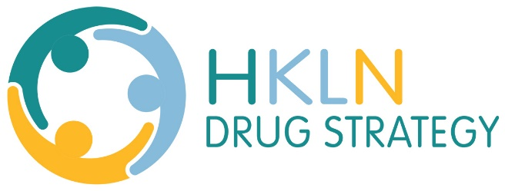
Treatment: Substance Use and Mental Health
FourCAST
Is a community based addiction treatment provider.
Office locations are in the counties of Peterborough, Northumberland, Haliburton and the City of Kawartha Lakes. They provide support for individuals and family members with alcohol, drug or gambling related problems through a number of programming options. They will work with you to develop a treatment path that is right for you.
For the site nearest you, call 1-800-461-1909 or visit: http://www.fourcast.ca/
CMHA HKPR
Offers mental health services throughout the four county area. In partnership with clients, families and the community, they provide best practice services through education, advocacy, therapeutic supports and assistance with social determinants, to improve mental health recovery and quality of life.
Peterborough – (705) 748-6711 or 1 (866) 990-9956
Kawartha Lakes – (705) 328-2704 or 1 (888) 454-8875
Administrative Office – (705) 748-6687
http://cmhahkpr.ca/
ConnexOntario
(see info above)
Green Wood Coalition
Is a radically inclusive, street-level organization that uses a community model of caring to walk alongside people who are hungry, homeless and hurting in Port Hope.
905-885-8700
http://www.greenwoodcoalition.com/
John Howard Society of Kawartha Lakes and Haliburton
The Society is a non-profit, multi service organization with offices located in Lindsay and Minden. Through prevention, education, and interventions JHSCKLH works with at risk youth and adults through a variety of programs and services.
705.328.0472
http://johnhoward.on.ca/kawartha/
Lakeridge Health
Offers a range of mental health and addictions services in Durham Region and Scarborough from several locations, by over 300 staff and physicians. Their detox service is open to any residents of the three county area.
https://www.lakeridgehealth.on.ca/en/ourservices/resources/Mental-Health-/MH-and-Pinewood-brochure–FINAL-Sept.-27.pdf
Rapid Access Addiction Medicine (RAAM) Clinics
Offer fast access to quality care on a walk-in basis for people living with alcohol and opioid-related addictions. Services include medical treatment and same-day counselling services without a doctor’s referral.
Located at: 159 King St. Suite 302 K9J 2R8, Peterborough, ON
t: 705-749-9708 f: 705-748-3060
Monday, Wednesday & Friday 8 a.m. to 11:00 a.m.
PARN (Peterborough AIDS Resource Network)
Provides free harm reduction supplies to people who use injection and inhalation drugs in order to reduce the risk of HIV transmission and other blood-borne infections.
To learn more about their Harm Reduction services, please click the link below or contact them at 705-749-9110 or 1-800-361-2895
http://parn.ca/harm-reduction/
Nogojiwanong Friendship Centre
Offers a cultural space for individuals with mental health and addictions issues to find the help they need in moving towards a healthier lifestyle. The programs offer one-on-one supportive counselling and consultation regarding treatment options and culturally based services and support groups, including holistic healing through medicine wheel teachings on physical, mental, emotional and spiritual health, and participation in cultural activities such as drumming circles, ceremonies, and feasts.
(705) 775-0387
http://www.nogofc.ca/services/health/addictions-and-mental-health/
Northumberland Hills Hospital Community Mental Health Services
Assists individuals who are experiencing mild to severe mental health concerns. Programming is geared to those 16 years and older. Individuals younger than 16 are eligible for selected services in some circumstances. Counselling services are available for those coping with mild to moderate mental health issues. Self-referrals are accepted, as are referrals from family physicians, the Hospital and community agencies.
905-377-9891 or 1-888-294-7579
https://nhh.ca/Patients/PatientCareServices/OutpatientCare/CommunityMentalHealth
The Ontario Addiction Treatment Centre
Offers methadone treatment in Port Hope, Lindsay and Haliburton.
1-877-937-2282
https://www.oatc.ca/
Port Hope Northumberland Community Health Centre
A is a community-centred primary health care facility. The Centre continues to accept new clients. Special consideration will be given to our target populations who do not have a family physician. These include:
- Seniors with more than one chronic disease
- Youth at risk between the ages of 12 to 21
- Those struggling with mental health and addictions
- Those receiving social assistance
905-885-2626
http://porthopechc.ca/
The Salvation Army
The Salvation Army in Port Hope and Cobourg offers supports around housing, food and addictions for those interested.
705-372-3832
http://www.tsacobourg.com/
Victoria and Haliburton Alcoholics Anonymous
At meetings AA members share their recovery experience with anyone seeking help with a drinking problem, and give individual services or “sponsorship” to the alcoholics coming to AA.
https://district82aa.org/Meeting-Locations.html
Northumberland Alcoholics Anonymous
https://www.quintewestaa.org/
Narcotics Anonymous
A non-profit fellowship or society of men and women for whom drugs has become a major problem.
http://www.orscna.org/english/area_meetings.php?id=6

