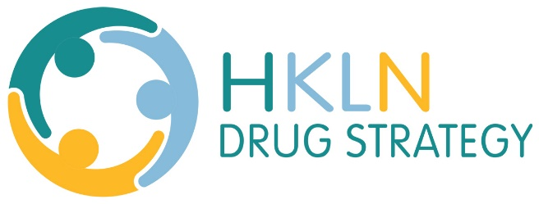
Youth Resource Guide
The Boys and Girls Club in Kawartha Lakes
Provides access to many different support services for children, youth and families. Support services include transition, school re-integration, prevention and intervention supports; restorative practices
705-324-4493
www.bgckl.com
Chimo Youth and Family Services
Strengthening the ability of children and youth to effectively deal with and/or resolve their mental health challenges, building resiliency for the future. They offer services primarily in Kawartha Lakes but also have some services available in Haliburton and Northumberland.
Tel: 705-324-3300
Toll Free: 1-877-661-2973
http://chimoyouth.ca/
Point in Time Centre for Children, Youth and Parents
Identifies needs, provides supports, and services enabling residents of Haliburton County to function at their highest potential.
Haliburton 705-457-5345
Minden (by appointment) 705-286-2191
Crisis Line (after 4:30pm) 1-866-995-9933
https://www.pointintime.ca/
EarlyON Child and Family Centre
Centres located throughout Haliburton and Kawartha Lakes offer parent and child activities for kids 0-6.
705-324-7900
http://oeyc.ca/
Rebound Child and Youth Services Offering mental health support for youth 4-18 in Northumberland County. These services include literacy and learning supports, youth justice and court diversion, and parenting supports.
905.372.0007
www.rcys.ca

