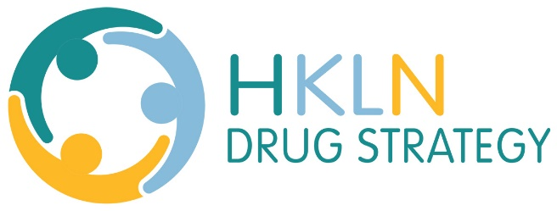
Culturally Specific Resource Guide
Alderville First Nation
Offers mental health and substance use supports for their community members.
905-352-2011
http://alderville.ca/
Niijkiwendidaa Anishnaabekwag Services Circle (NASC)
A not-for-profit organization dedicated to the development and delivery of healing services for Anishnaabekwewag and their families who have been abused, are being abused, or are at risk of being abused. Healing work is conducted through the use of traditional Anishnaabe spirituality, blended with other appropriate methods of healing. Serving the HKPR region.
NASC provides services to the following geographic areas of this great and sacred Turtle Island:
Main Line: 705-741-0900
Toll Free: 1-800-663-2696
http://www.niijki.com/
Dnaagdawenmag Binnoojiiyag Child & Family Services
Offers a Child & Youth Mental Health and Addictions program in Alderville First Nation. The program provides culturally appropriate support services to children, youth (up to age 24) and their families experiencing mental health and addictions difficulties.
The Native Youth Justice program services First Nation/Indigenous youth between the ages of 12 – 17 who are in conflict with the law, using culturally-based healing supports to help youths reach rehabilitation and reintegration.
https://www.binnoojiiyag.ca/
The Nogojiwanong Friendship Centre
Offers a Court Worker Program offered to people living in the HKPR region. The goal of the Court Worker Program is to assist in reducing the over representation of Aboriginal people in the justice system, by assisting Aboriginal individuals to better understand their rights, options and responsibilities when appearing before the courts. The program can assist adults and youth charged with a criminal offense; separating couples; and parents involved in child welfare matters.
https://www.nogofc.ca/services/court-worker-program/
Cultural Competency training opportunities in HKPR:
- The Safe Guards Training Program offers training locally on topics related to intergenerational trauma, as well as custom, in-service training with agencies
safeguards-training.net/Training/
- Trainings are also offered to HKPR service providers through the Nogojiwanong Friendship Centre in Peterborough
- The Ontario Indigenous Cultural Safety Program is offered Ontario-wide and administered by the Southwest Ontario Aboriginal Health Access Centre
http://soahac.on.ca/ICS-training/
- Training is also offered through the Ontario Federation of Indigenous Friendship Centres http://www.ofifc.org

